Python Assignment - 3
Instructions to students:
- Solve the given problems and upload results into git-hub account (.pynb file)
Assignment:
- Area of Triangle :
Given the lengths of three sides of a triangle, calculate the area of the triangle.
- Take a string from end user and check if the value is palindrome or not
- Write a program that reads a year from the user and displays a message
Indicating whether or not it is a leap year.
- Space To Hyphen problem
Take a string as input, and replaces spaces “ “ with hyphens “-”, and returns a string.
Input: “ This program converts spaces into hyphen”
Output: “ This-program-converts-spaces-into-hyphen”
- Unique Sort problem
Take a string as input that accepts a comma separated sequence of words as input and prints the unique words in sorted form (alphanumerically).
*Input*: orange, white, red, cyan, green, magenta, cyan, pink, white
*Output*: cyan, green, magenta, orange, pink, red, white

- Tax Calculator
Ask the user for their monthly salary. Calculate whether they have to pay tax and if so, how much is that amount .Print the result
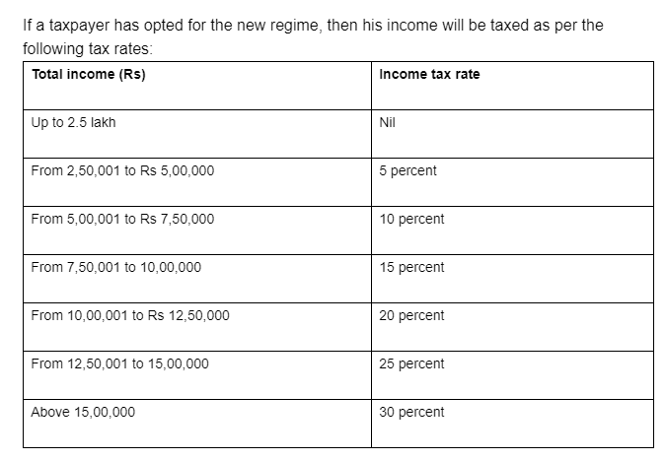
- Take a list of integers as an argument, and converts it into a single integer (return the integer).
*Input*: [11, 33, 50]
*Output*: 113350

- Units of Time
Create a program that reads duration from the user as a number of days, hours, minutes, and seconds. Compute and display the total number of seconds represented by this duration.
- Sort 3 Integers
Given three integers (given through user input), sort the numbers using |min| and |max| functions.
- Write a program that reads a date from the user and computes its immediate successor. The date is the format YYYY-MM-DD. So, 2020-04-15 will have the successor 2020-04-16.
- Compute product of a list of numbers [45 ,3,2,89,72,1,10,7]
Output: 121111200
- Compute given Num_list = [5, 6,8 ,34,89,1] to get desired output
Output: Out_list=[11,14,42,123,90]
- Compute given Num_tuple = (5, 6,8 ,3,9,1) to get desired output
Output: Out_list = [5, 30, 240, 720, 6480, 6480]
- Write a Python code that takes a number and returns a list of its digits. So for 586392 it should return [5,8,6,3,9,2]
- Write a program that finds the longest palindromic substring of a given string

- Substring Check (Bug Funny)
Given two binary strings, A (of length 10) and B (of length 5), output 1 if B is a substring of A and 0 otherwise.
First two lines of input:
1010110010 10110
1110111011 10011
First two lines of output:
1
0
- POUR1 - Pouring water
Given two vessels, one of which can accommodate a litres of water and the other - b litres of water, determine the number of steps required to obtain exactly c litres of water in one of the vessels.
At the beginning both vessels are empty. The following operations are counted as 'steps':
- emptying a vessel,
- filling a vessel,
- pouring water from one vessel to the other, without spilling, until one of the vessels is either full or empty.

Input
An integer t, 1<=t<=100, denoting the number of testcases , followed by t sets of input data, each consisting of three positive integers a, b, c, not larger than 40000, given in separate lines.

Output
For each set of input data, output the minimum number of steps required to obtain c litres, or -1 if this is impossible.

Example
Sample input:
2
5
2
3
2
3
4

Sample output:
2
-1

